Fltterning json data 4

Dataset 4= emp_details_3

[

{

"id":"101",

"name":"srinivas",

"gender":"male",

"phonenumber":9999

},

{

"id":"102",

"name":"phani",

"gender":"male",

"location":"Hyderabad"

}

]

Here in this dataset phone is available in first but not location similarly in second location is available but not phone no

1. Add source like previously

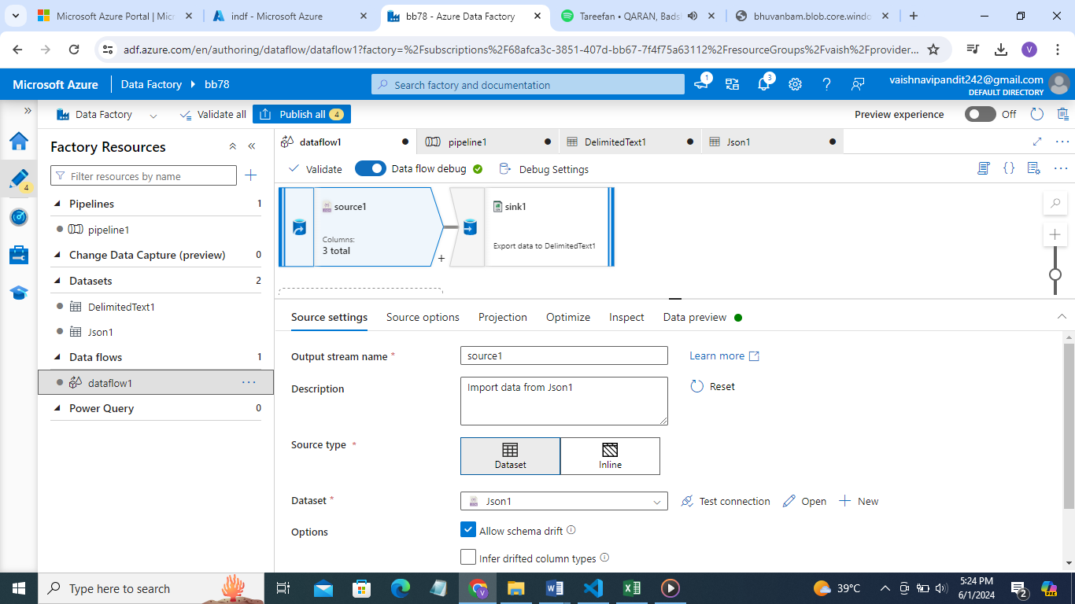

1. Select source option->json settings->array documents

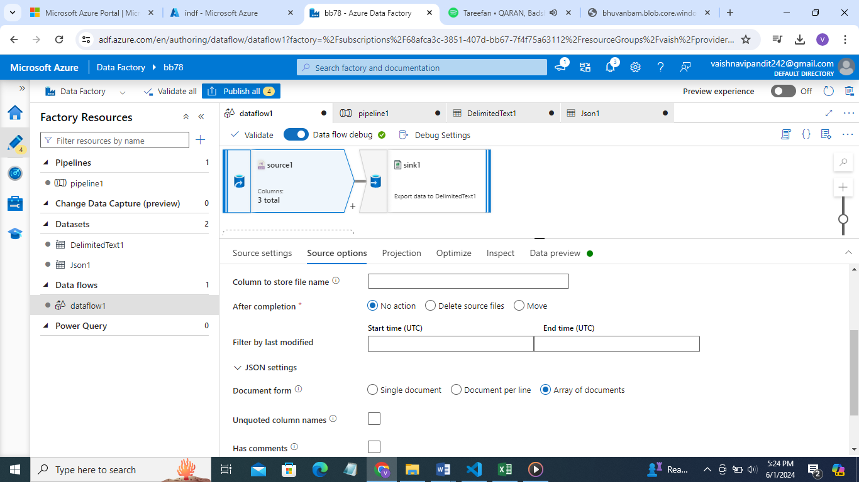

1. Now go and see preview

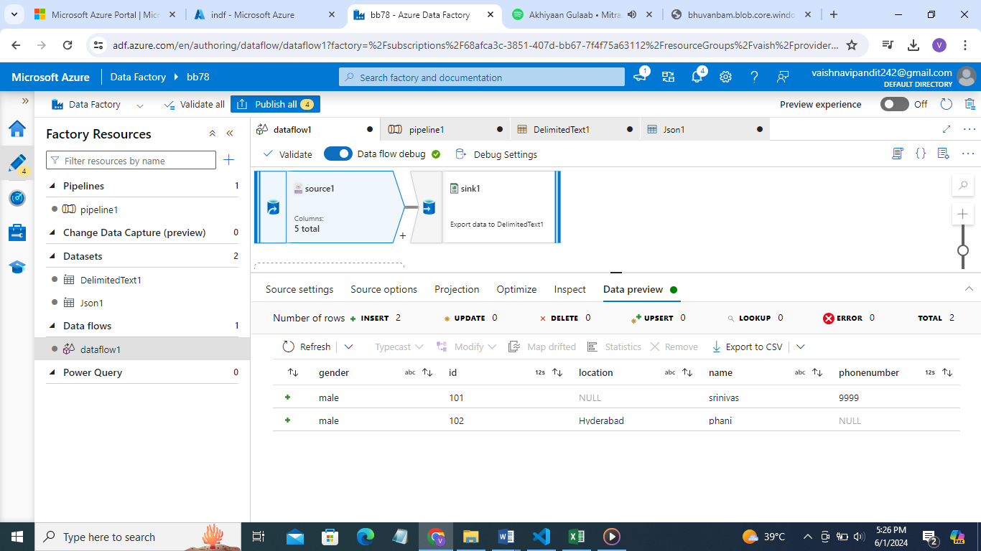

Those values which are not available it will show null in place of that

Now add sink and pipeline publish debug